**Practice-1**

**Aim: WAP to create a Message class with a constructor that takes a single string with a default value. Create a private member string, and in the constructor simply assign the argument string to your internal string. Create two overloaded member functions called print( ): one that takes no arguments and simply prints the message stored in the object, and one that takes a string argument, which it prints in addition to the internal message.**

**Program:**

#include<iostream>

#include<string.h>

using namespace std;

class message

{

private :

char member[100];

public :

message (char h[])

{

strcpy(this->member,h);

}

void print()

{

cout << this->member<<endl;

}

void print(char r[])

{

cout << r <<endl;

}

};

int main()

{

message m1("my name is hardik");

m1.print();

m1.print("my surname rathod");

return 0;

}

**Output:**

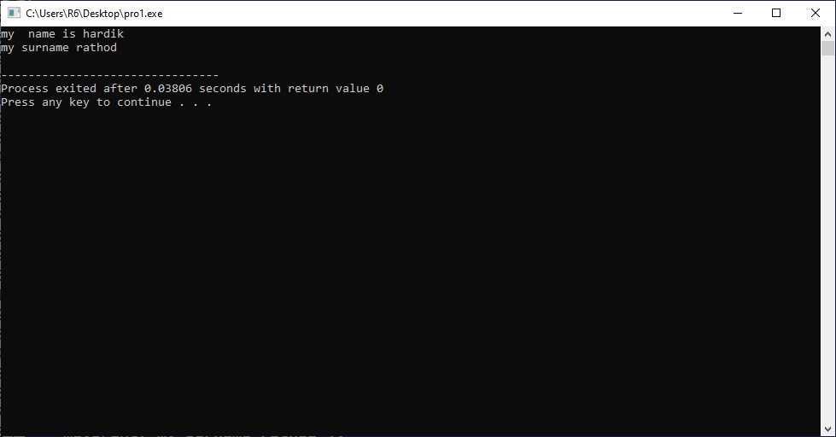

**Practice-2**

**Aim:WAP which illustrate the use of Method Overriding concept.**

**Promgram:**

#include<iostream>

using namespace std;

class animal

{

public:

void dog()

{

cout<<"dog's name is sheru."<<endl;

cout<<"dog's age is 3."<<endl;

}

};

class wildanimal: public animal

{

public:

void tiger()

{

cout <<"tiger's name is tommy."<<endl;

cout <<"tiger's age is 6. "<<endl;

cout << "================================="<<endl;

animal::dog();

}

};

int main()

{

wildanimal w1;

w1.tiger();

return 0;

}

**Output:**

